**Understanding the investment dimension**

June 2017 • Standards of Evidence

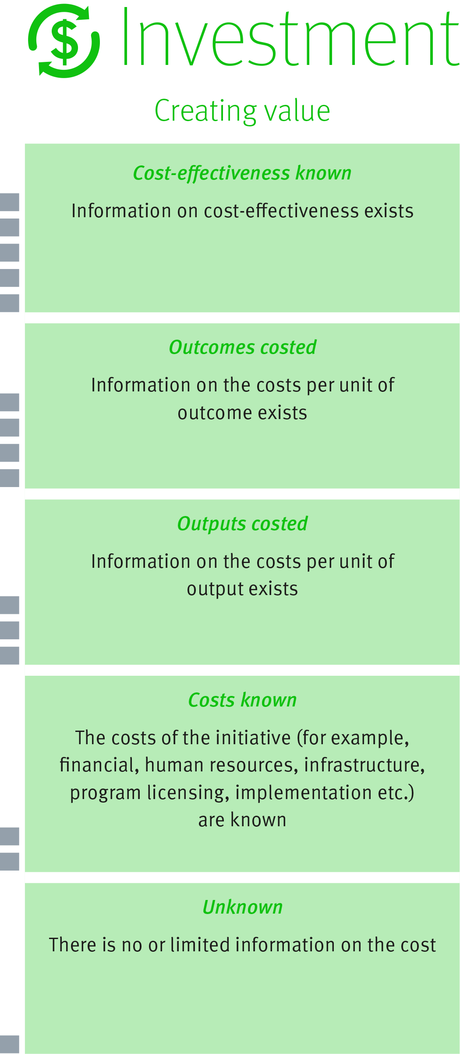

The investment dimension of the Standards of Evidence provides information about the cost and value of an initiative.

Understanding the impact of initiatives relative to their costs can inform decisions about where best to invest our financial and human resources.

The investment dimension contains five levels indicating the degree of information about cost, with the higher levels also considering value. (See diagram to the right)

**Strength of Evidence**

Levels one and two demonstrate an understanding of the costs of an initiative. Levels three and four demonstrate there is information regarding the value or return on that cost. At level five, there is information comparing the costs and value of an initiative. The levels do not show increasing cost-effectiveness.

The following pages provide examples and case studies of how these levels can be applied.

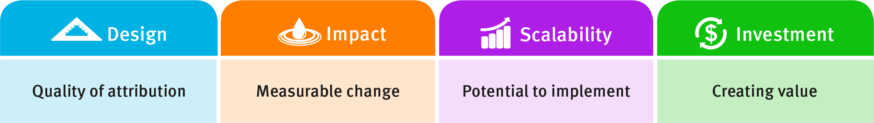

## Understanding the levels

When calculating investment, it is important to exclude usual operating costs (e.g. teacher’s salary) and only include the costs incurred in implementing the initiative.

**Unknown – level one**

At level one, there is no, or limited information, on costs. Level 1 may or may not include a description of the resources required, or an estimate of total costs. For example:

* Total staff time – 10 days.

**Costs known – level two**

At level two, the costs of the initiative are listed and totalled without any detail about the costs per output or outcome. For example:

* Cost of program $3000
* Headsets $ 200
* Total expenditure $3200

**Outputs costed – level 3**

At this level, investment information should include costs per outputs (e.g. cost per participant). This is helpful when considering affordability. For example:

* Program cost per participant $300
* Headset per participant $ 20
* Total expenditure per participant $320

**Outcomes costed – level four**

To reach level four, investment information should include total costs relative to the outcomes of the initiative (i.e. the measured impact on individuals or groups). For example:

* The cost of $440 per participant was associated with an average 3 per cent increase in scores on a standardised numeracy test compared to a similar group of students. This represented an average cost of $147 per percentage point increase per student.
* A $50,000 investment was associated with an increase of 1000 more Certificate III completions than in the previous year. This equates to an average cost of $50 per additional completion.

**Cost-effectiveness known – level five**

Information on cost-effectiveness provides powerful evidence to inform decision making. At level five, the initiative must include information aligning costs to measurable outcomes, and comparing this to other initiatives whose cost-effectiveness is measured in the same way. The same approach must be taken with the cost and impact calculations of each initiative so the comparisons are meaningful. For example:

* The outcomes of a particular numeracy initiative cost an average of $147 per percentage point increase per student. This compares to other evidence-based approaches designed to improve numeracy, whose costs range between $40 – $300 per percentage point increase per student.
* The overall program investment of $50,000 was associated with an increase of 1000 more Certificate III completions than in previous years. The average cost of $50 per participant per additional completion compares favourably to similar programs with an average cost of $100.

## Case study one

This example is considered to meet level four (Outcomes costed) on the investment dimension because it provides the cost per unit of outcome.

The *Skilling Queenslanders for Work*[1] (SQW) employment initiative was introduced in 2007 to overcome challenges in labour force participation, particularly amongst disadvantaged groups.

An evaluation of SQW found that of 57,000 people who gained work through SQW, 8500 would not have found employment without the program.

The investment of about $90 million a year added about $3.4 billion to the Queensland economy, as a result of the additional 8 500 who became gainfully employed rather than welfare recipients.

The benefit-to-cost ratio was 7.6 over 10 years which means a return of $7.60 on every dollar invested. The evaluation also found:

* SQW delivered significant social value by improving physical and mental wellbeing and intergenerational benefits
* the social benefits of the program also translated into wider economic benefits over the longer term including reduced health and social service costs and savings in the criminal justice system.

The evaluation projected that SQW would yield a further $1.2 billion in state tax receipts by 2020.

## Case study two

This example is considered to meet level five (Cost effective) as it calculates the cost-effectiveness of rapid assessment relative to other initiatives.

In 2010[2], Stuart Yeh evaluated the relative cost-effectiveness of 22 initiatives focused on improving student outcomes such as rapid assessment (involving systems where rapid and frequent feedback on performance is given to students). This was compared to a longer school day, cross-age tutoring, increases in teacher education and voucher programs.

Cost-effectiveness ratios for each initiative were calculated by dividing the annual effect size gain by the cost per student. Yeh found that rapid assessment was more cost effective than any of the 21 alternative initiatives examined.

**Ways of measuring value**

There are a number of ways to measure investment and the value of your initiative. Cost-effectiveness analysis and benefit-cost analysis are two approaches.

|  |  |
| --- | --- |
| Cost-effectiveness analysis (levels three, four and five) | Benefit-cost analysis (levels four and five) |
| This method allows the dollar cost of one initiative to be compared to the cost of other initiatives if a common unit of outcome exists.  Cost-effectiveness analysis is useful in situations where initiatives have shared objectives.  The aim is to identify the most cost-effective initiative to achieve a desired outcome.  ore costly, less impact | This method compares the financial, economic, environmental and social benefits and costs of an initiative.  Initiatives are compared with a scenario based on what may have happened if it was not implemented.  Monetary estimates of both benefits and costs are required. |

1. Deloitte Access Economics (2012) ‘Evaluation of Skilling Queenslanders for Work’. Retrieved from: [https://det.qld.gov.au/det-publications/reports/Documents/evaluation/evaluation-skilling-queenslanders-work.pdf](https://qed.qld.gov.au/det-publications/reports/Documents/evaluation/evaluation-skilling-queenslanders-work.pdf)
2. Yeh, S. (2010) ‘The Cost Effectiveness of 22 Approaches for Raising Student Achievement’. Retrieved from

   <https://works.bepress.com/stuart_yeh/2/>