June 2017 • Standards of Evidence

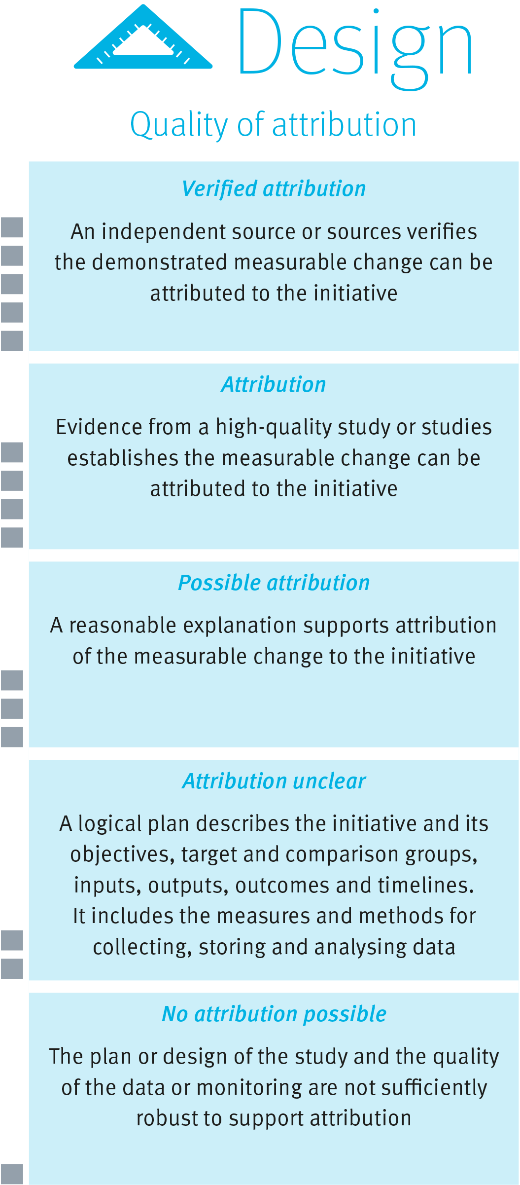

Understanding the design dimension
The design dimension of the Standards of Evidence provides information about the extent to which any measurable change can be attributed to an initiative.
The ability to attribute any measurable change to an initiative is linked to, and dependent upon, the initiative’s design, supported by quality data.
The design dimension contains five levels that indicate the relative strength of evidence of attribution (See diagram to the right).
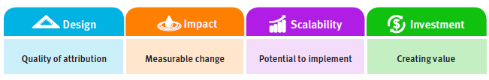

Strength of Evidence

How to design for a high-quality study

There is no study design that is appropriate for use in all situations. The design should be tailored and proportionate to the initiative’s objectives, available resources and context. Quality design helps remove doubt about attribution. During the planning stage, consider the points below.

- Understand the issue and develop possible options
Scan and assess all available evidence to identify opportunities for improvement or innovation. Prioritise your focus on the most significant area for improvement.

Clearly identifying the issue helps inform your decision about the preferred option for responding to that issue. Access available research to identify a range of evidence-based alternative responses before developing an initiative best suited to your context.

- Make sure the initiative’s objectives, outputs and outcomes are measurable
Be clear about what the initiative is trying to achieve; what success will look like (that is, the desired change in outcomes) and how this will be measured. An initiative’s objectives must be clearly articulated and be specific, measurable, achievable, relevant and time-bound.

While objectives such as ‘deepened learning experiences’ or ‘delivering a high-performing, quality workforce’ are worthy, they are not easily measurable. It is important to have a logical alignment between the department’s strategic objectives and an initiative’s objectives, implementation strategies, measures and outcomes.

- Select appropriate measures and methods
Many measures and methods exist to generate, collect and analyse evidence or data. The choice of measures and data collection and analysis
methods will be influenced by the context within which an initiative operates. When looking at measures consider if they are valid and reliable.

- Identify a baseline measure
A baseline measure is a reference point from before the initiative is implemented and against which change can be measured. Without a baseline measure, it is impossible to measure the extent of change. Ideally, baseline measures should be available for both a target group and a comparison group.

- Choose target and comparison groups of sufficient size
Where possible, select target and comparison groups using methods which minimise the potential for bias. Try to ensure the groups are as similar or representative as possible. While the exact size of the target and comparison groups may vary depending on the study’s design, a rule of thumb is that both groups should include at least 20 individuals.

Comparison data helps clarify what change in performance could have been expected without the initiative and therefore strengthens any claims about impact. Comparison data can be drawn from various sources including data from comparison groups, historical data for similar groups and norm-referenced data.

- Use multiple sources of evidence
External factors can influence any potential change in outcomes. Wherever possible, identify evidence or data sources which isolate the influence of other factors, to make an accurate assessment of change.

Use of multiple sources of evidence and both qualitative and quantitative outcome measures can be a way of strengthening confidence in attributing change to the initiative.

The methods by which evidence or data are collected can also
serve to strengthen confidence that any findings are accurate
and replicable over time.

Understanding the levels

When evaluating design, it is important to consider the size and composition of the target group and any comparison group; the appropriateness of the measures selected and their alignment with planned activities; and how impact will be, or has been, measured.

No attribution possible – level one
At this level, a plan may provide a brief rationale for the initiative but the data presented is not aligned to the objectives or the findings are inconsistent.

Attribution unclear – level two
A logical plan exists describing the initiative’s objectives; inputs; outputs; and outcomes, detailing groups on which data is collected. However, there is limited documentation connecting the objectives and strategies with an improvement in outcomes.

Possible attribution – level three
There is sufficient documentation and quality evidence to support a claim that the strategies undertaken in the initiative contributed in some way to the outcomes.

Attribution – level four
The initiative has an evidence base and clear alignment between the objectives, strategies and measures. The study employs valid and reliable data collection and analysis methods and accounts for the influence of external factors. One or more high-quality studies clearly demonstrate that the measurable change can be attributed to the initiative.

Verified attribution– level five
At this level, an independent source (or sources) verifies the demonstrated measurable change can be attributed to the initiative. Independent verification provides the highest level of confidence in claims of attribution.

