June 2017 • Standards of Evidence
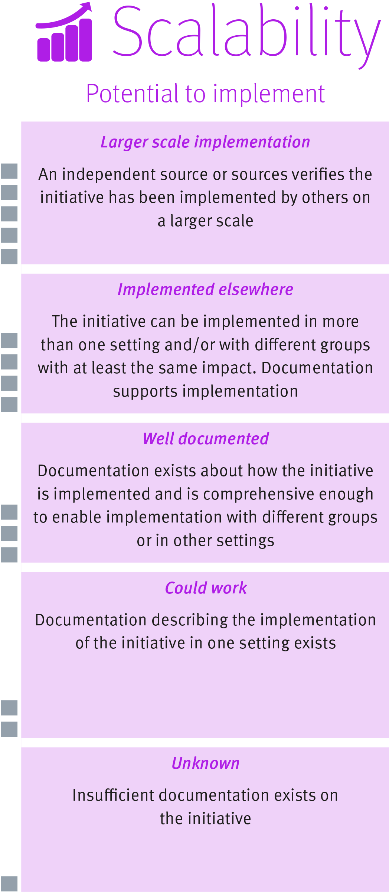

Understanding the scalability dimension
The scalability dimension of the Standards of Evidence provides information about the extent an initiative can be implemented in different settings or with other groups, while achieving the same or consistent impact.
Understanding scalability helps to plan documentation processes during the design phase of an initiative.
Strength of evidence
Detailed information about the implementation process lets others know the ease with which an initiative could be, or has been scaled. This documentation also plays an important role in securing attribution and likely impact.
Not everything can or should be scaled. The other dimensions of the Standards of Evidence and the operational parameters of your local context should be used to determine suitability to scale.
The scalability dimension contains five levels that indicate the relative strength of evidence of scalability. (See diagram to the right)

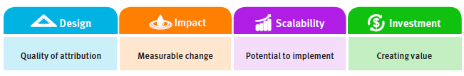

Before you scale

Scaling an initiative, across different settings or with different groups, requires time and effort and is not always appropriate or practical. Scalability is concerned with how clearly the model of implementation for the initiative has been documented and articulated. This documentation also assists in strengthening the claim of attribution and supporting consistency and fidelity in implementation.

A clearly articulated model of implementation may include: manuals or facilitator guides, implementation resources, professional learning materials, estimated inputs and/or reporting guides. The quality and detail of this information will support the fidelity of an initiative’s delivery across new settings and groups.

The following questions can guide documentation of the model of implementation for an initiative:
- Are there environmental factors unique to the implementation of the initiative that influences its success?
- What are the key features that contributed to the initiative’s success that need to be retained? For example, funding, staffing with particular expertise, training, facilities, management or leadership approach.
- What are the underlying features critical to implementation? For example, level of collaboration between staff and stakeholders, stakeholder participation in decisions or effective feedback loops.
- What are the minimum standards that must be met for the initiative to consistently produce equivalent evidence of impact?

The following questions can help guide thinking about the practicality and feasibility of scaling an initiative:
- Is the initiative aligned to the department’s strategic objectives and priorities?
- Is there commitment across all levels to dedicate time and resources to scaling?
- Are there appropriate processes, structures, facilities, skills and capabilities to implement the initiative?
- Are the conditions compatible with supporting implementation at scale?
- Are the timeframes for scaling the initiative realistic?
- Is scaling the initiative sustainable over the longer term?

The following questions can help guide thinking about what organisational and personnel capacity is required for scaling an initiative:
- What factors need to be in place to support scaling?
- Does the team or organisation have the capacity to support and guide implementation elsewhere?
- Are there systems in place to support scaling?

Different ways to scale

There are different ways to scale initiatives and the following pathways are not exclusive and can be combined.

- Dissemination
This pathway involves communicating and promoting an initiative to generate interest, participation and scale. Dissemination could be achieved through providing advice, delivery of training to interested individuals or organisations or influencing organisations and individuals. This pathway offers a lower level of control over implementation of an initiative elsewhere, as it is dependent upon interested individuals or organisations scaling an initiative as advised.

- Expansion
Expansion focuses on growing the capacity of an organisation that has already implemented an initiative in one setting or with one group, to implement the initiative elsewhere. This might involve building staff capability or developing organisational capacity and systems to support scaling of the initiative. This pathway offers a higher level of control, as effort is generally planned and managed by the organisation, rather than individuals outside the organisation.

- Collaboration and partnerships
This pathway involves collaborating, forming alliances or partnering with other organisations, individuals or interested groups to support scaling. Collaborating and partnering can facilitate access to another organisation’s existing service infrastructure or skilled staff that may be necessary to scale an initiative. This pathway can help create a shared understanding of the initiative, but can require investment of time to facilitate consistent communication and collaboration.

- Networks
Networks or clusters bring interested people or organisations together and facilitate connections, sharing of good practice and transferring knowledge with the aim of supporting implementation elsewhere. This pathway can be used to generate momentum at the service delivery level.

Understanding the levels

Unknown – level one
At this level, no assessment about scale can be made due to limited information on how the initiative has been implemented in any setting.

Could work – level two
There is documentation detailing the implementation of the initiative in one setting but with some details missing. For example, details on what facilitator training entailed, or who provided it, may be missing.

Well-documented – level three
The model of implementation includes manuals, professional support materials or codified processes and procedures for delivery necessary to support implementation of the initiative.

Implemented elsewhere – level four
Evidence supports the model of implementation clearly demonstrating that the initiative has been implemented in more than one setting or with different groups achieving the same impact or better.

Larger scale implementation – level five
An independent source or sources verifies evidence demonstrating the initiative works on a larger scale, either with other groups or in other settings, achieving at least the same impact.

Deacon,C and Sellick, V (2016). What does it take to go BIG? Insights on scaling social innovation from the Centre for Social Action Innovation Fund. Retrieved from http://www.nesta.org.uk/publications/what-does-it-take-go-big-insights-scaling-social-innovation
Deacon, C and Sellick, V (2016). What does it take to go BIG? Insights on scaling social innovation from the Centre for Social Action Innovation Fund. Retrieved from http://www.nesta.org.uk/publications/what-does-it-take-go-big-insights-scaling-social-innovation

